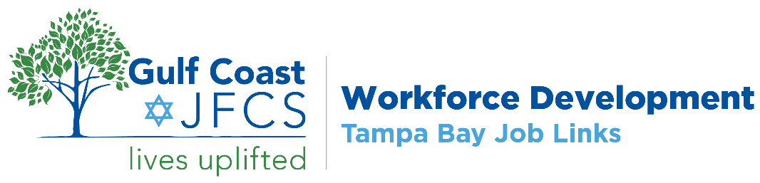

WORKSHEET ~ Craft A Powerful Professional BRAND
1. Skills & Strengths
🟦 What you’re great at - and what others recognize you for
- What are your strongest skills or areas of expertise?
- What kinds of work energize you?
- What accomplishments or results are you most proud of?
My key skills and strengths:

2. Approach & Personality
🟨 How you get things done - and how others experience working with you
- How do you approach work or problem-solving?
- What adjectives would others use to describe your personality at work?
- What’s your communication or collaboration style?
My approach and personality:

3. Values & Beliefs
🟥 What motivates you - and what you stand for
- What principles guide your decisions and actions?
- What kind of work feels most meaningful to you?
- What matters to you in a workplace or team?
My core values and beliefs:

4. Reputation & Visibility
🟩 What others say about you - and where your brand shows up
- What do past colleagues, managers, or clients say about you?
- Where can people “see” your brand in action (e.g., LinkedIn, resume, projects)?
- Are you showing up consistently with the brand you want to project?
My reputation and visibility:

🔍 Final Reflection
- What themes or patterns do you notice across all four areas?
- Is there anything missing or unclear that you want to develop further?

